**2a. IPO (Initial Public Offering) Process**

**2b. Securities Trading (e.g., stocks, bonds, derivatives)**

**(Presented By Alan Stuart K)**

**2a. IPO (Initial Public Offering) Process:**

**Introduction:**

An Initial Public Offering (IPO) is the process through which a private company offers its shares to the public for the first time. This pivotal event allows companies to raise capital from public investors, providing funds for expansion, debt repayment, and other corporate purposes. In the US banking sector, IPOs are facilitated by investment banks, which play a crucial role in underwriting, pricing, and distributing the shares. The IPO process is a significant milestone for companies, marking their transition to public ownership and enabling broader market participation.

**5-W Analysis:**

1. **Who:**
   * Companies seeking to raise capital and gain public market access.
   * Investment banks, investors, regulatory bodies, and stock exchanges.
   * Key stakeholders include company executives, shareholders, and investment bankers.
2. **What:**
   * The process of offering shares of a private company to the public through a stock exchange.
   * Involves steps like filing registration with the SEC, roadshows, pricing, and listing on an exchange.
3. **Where:**
   * Primarily occurs in major financial centres such as New York City.
   * Shares are listed on stock exchanges like the New York Stock Exchange (NYSE) or NASDAQ.
4. **When:**
   * Companies typically go public during favourable market conditions to maximize valuation and investor interest.
   * The process involves several months of preparation and regulatory compliance.
5. **Why:**
   * To raise substantial capital for growth, acquisitions, debt reduction, or other strategic initiatives.
   * Provides liquidity for existing shareholders and enhances company visibility and credibility.

**Applications:**

* **Capital Raising:** IPOs allow companies to secure significant funding for expansion, research and development, and other growth initiatives.
* **Market Visibility:** Public companies gain increased visibility, which can enhance their reputation and attract more business.
* **Liquidity:** Provides an exit strategy for early investors and employees by allowing them to sell their shares in the open market.
* **Valuation:** Establishes a market-based valuation of the company, which can be used for future fundraising or acquisitions.
* **Corporate Governance:** Public companies often adopt stricter governance standards, which can improve management practices and transparency.

**Data:** IPO (Initial Public Offering) Process:

| **Stage** | **Description** | **Timeline** | **Key Metrics** |
| --- | --- | --- | --- |
| **Pre-IPO Planning** | **Company preparation and selection of underwriters** | **6-12 months** | **80% of companies take 1+ years to prepare** |
| **Due Diligence** | **Comprehensive review of company financials and operations** | **3-6 months** | **1000+ hours of work typically** |
| **SEC Filing** | **Submission of S-1 registration statement** | **1-2 months** | **90% of IPOs require multiple amendments** |
| **Marketing** | **Road shows and investor presentations** | **2-3 weeks** | **50-100 investor meetings on average** |
| **Pricing** | **Setting the final share price** | **1-2 days** | **80% of IPOs price within expected range** |
| **Allocation** | **Distribution of shares to investors** | **1 day** | **Institutional investors get 70-80% of shares** |
| **Trading Begins** | **First day of public trading** | **1 day** | **Average first-day pop: 10-15%** |
| **Quiet Period** | **Restrictions on company communications** | **40 days** | **90% of analysts initiate coverage after this** |

**2b. Securities Trading (e.g., stocks, bonds, derivatives):**

**Introduction:**

Securities trading involves the buying and selling of financial instruments such as stocks, bonds, and derivatives. This activity is fundamental to the functioning of financial markets, providing liquidity, price discovery, and opportunities for investment and risk management. In the US banking sector, securities trading is conducted by individual investors, institutional investors, and trading desks within banks. It is facilitated by exchanges like the NYSE and NASDAQ, as well as over-the-counter (OTC) markets.

**5-W Analysis:**

1. **Who:**
   * Individual investors, institutional investors, and trading desks within banks.
   * Key players include retail traders, hedge funds, mutual funds, and proprietary trading firms.
2. **What:**
   * The process of buying and selling financial instruments, including stocks, bonds, options, futures, and other derivatives.
   * Involves trading for investment, speculation, hedging, and arbitrage purposes.
3. **Where:**
   * Conducted on stock exchanges (e.g., NYSE, NASDAQ) and OTC markets.
   * Trading can be done electronically or through trading floors in major financial centres.
4. **When:**
   * Trading occurs during exchange operating hours, with extended hours for pre-market and after-market trading.
   * Continuous activity, influenced by market news, economic data, and corporate events.
5. **Why:**
   * To invest capital, manage risk, and achieve financial returns.
   * Facilitates liquidity, price discovery, and efficient allocation of capital in the economy.

**Applications:**

* **Investment:** Investors buy securities to generate returns through capital gains, dividends, and interest payments.
* **Risk Management:** Derivatives like options and futures allow market participants to hedge against price fluctuations and manage risk.
* **Speculation:** Traders speculate on price movements to profit from short-term market volatility.
* **Arbitrage:** Exploit price differences in different markets or instruments to earn risk-free profits.
* **Market Liquidity:** Active trading ensures that securities can be bought and sold quickly without significantly affecting prices.

**Data:** Securities Trading:

| **Type** | **Description** | **Daily Volume** | **Key Metrics** |
| --- | --- | --- | --- |
| **Stocks** | **Equity shares of companies** | **$200-300 billion** | **50% of volume from algorithmic trading** |
| **Bonds** | **Debt securities** | **$600-800 billion** | **80% of corporate bond trading is OTC** |
| **Derivatives** | **Contracts based on underlying assets** | **$5-7 trillion notional** | **Options make up 60% of listed derivatives** |
| **ETFs** | **Exchange-traded funds** | **$100-150 billion** | **30% of US equity trading volume** |
| **Forex** | **Foreign exchange** | **$6-7 trillion** | **80% of volume from top 10 currency pairs** |
| **Commodities** | **Raw materials and agricultural products** | **$50-100 billion** | **70% of volume in energy products** |

**Graphs:**

**Graph 1:** Number of IPOs Over Time:

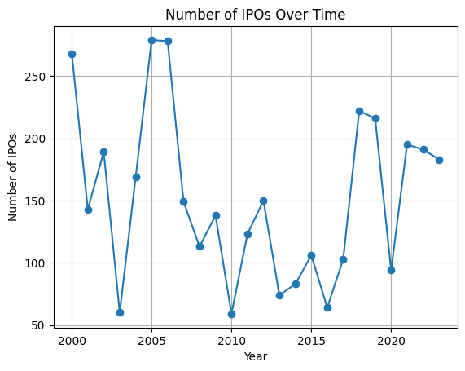**Inference:**

This line chart shows the number of IPOs from 2000 to 2023. The data reveals significant fluctuations, with notable peaks and troughs reflecting varying market conditions and economic cycles. For instance, the early 2000s and the mid-2010s exhibit high numbers of IPOs, corresponding to periods of economic expansion and investor optimism. Conversely, the sharp decline around 2008 corresponds to the financial crisis, highlighting the impact of economic downturns on IPO activity. The recent upward trend indicates a resurgence in IPO activity, driven by favourable market conditions, technological advancements, and investor appetite for new public offerings. Overall, the cyclic nature of IPOs underscores their sensitivity to broader economic and market trends.

**Graph 2:** Average IPO Size by Industry:

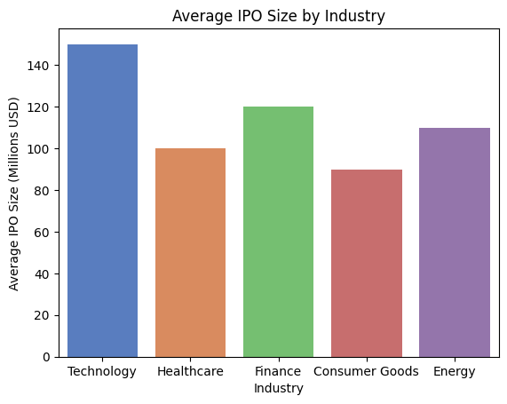**Inference:**

This bar chart illustrates the average IPO size across different industries. The Technology sector leads with the highest average IPO size of $150 million, reflecting the substantial capital requirements and investor interest in tech companies. Healthcare follows with an average IPO size of $100 million, driven by advancements in medical technology and pharmaceuticals. The Finance and Energy sectors also show significant IPO sizes, at $120 million and $110 million respectively, indicating robust capital raising activities in these industries. Consumer Goods, with an average IPO size of $90 million, demonstrates steady but lower capital needs. This distribution highlights the varying capital requirements and investor preferences across different sectors, with technology and healthcare being particularly prominent.

**Graph 3:** Trading Volume of Stocks Over Time:

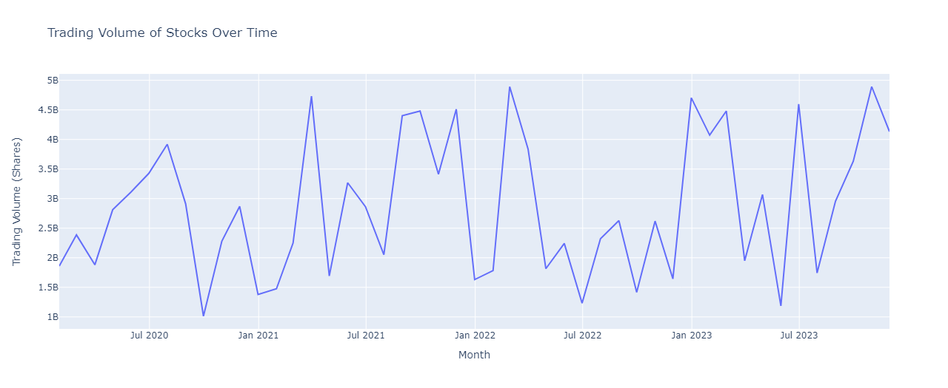**Inference:**

This line chart presents the trading volume of stocks from January 2020 to December 2023. The data indicates substantial fluctuations in trading volume, with certain periods exhibiting sharp increases, possibly due to market volatility, economic events, or significant corporate announcements. For example, the spikes in trading volume in early 2020 likely correspond to the market reactions to the COVID-19 pandemic, while other peaks may be related to specific events such as elections, regulatory changes, or major earnings reports. The overall trend shows a dynamic and responsive stock market, with trading volumes reflecting investor sentiment, market conditions, and external events. This highlights the importance of monitoring trading volumes for understanding market activity and investor behaviour.

**Graph 4:** Yield Curve for Different Bond Maturities:

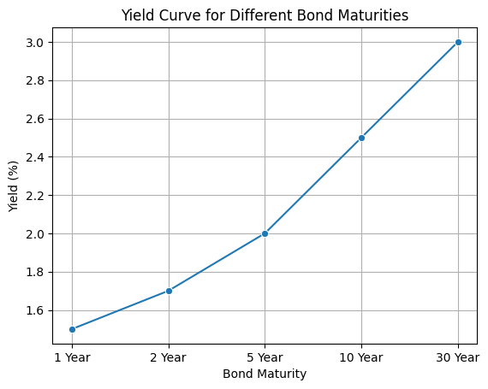**Inference:**

This line chart illustrates the yield curve for different bond maturities, ranging from 1 year to 30 years. The upward-sloping curve indicates that longer-term bonds offer higher yields compared to shorter-term bonds, reflecting the risk premium associated with longer maturities. For instance, the 1-year bond yields 1.5%, while the 30-year bond yields 3.0%. This yield curve shape is typical of a healthy, expanding economy where investors demand higher returns for taking on longer-term risks. The relatively steep increase in yields from short to long maturities suggests investor confidence in future economic growth and inflation expectations. This information is crucial for investors and policymakers as it provides insights into market expectations and economic outlooks.

**Conclusion:**

The IPO process and securities trading are cornerstone activities within the US banking sector, playing vital roles in capital formation, market liquidity, and economic growth. The IPO process enables private companies to transition to public ownership, raising substantial capital for expansion and enhancing corporate visibility and credibility. Investment banks facilitate this complex process, ensuring regulatory compliance, appropriate pricing, and successful market entry. Securities trading, encompassing the buying and selling of stocks, bonds, and derivatives, is fundamental to market efficiency, providing liquidity, price discovery, and investment opportunities. It involves a diverse range of participants, from individual investors to institutional traders, and is conducted on major exchanges like the NYSE and NASDAQ as well as OTC markets. This trading activity supports investment, risk management, speculation, and arbitrage, contributing to the dynamic and responsive nature of financial markets. Together, IPOs and securities trading drive economic development, foster corporate growth, and enable efficient capital allocation, underscoring their critical importance in the US banking sector and broader economy.